**Download and Installation**

**Download**

1. Download the document: “Model_GUSignal” and the zip file: “Model_GUSignal.prj” attached.

**Installation**

1. Unzip the file “Model_GUSignal”
2. Open the folder “Model_GUSignal”
3. Open the folder “for_redistribution”
4. Double click on “MyAppInstaller_web”. This will start the installation.

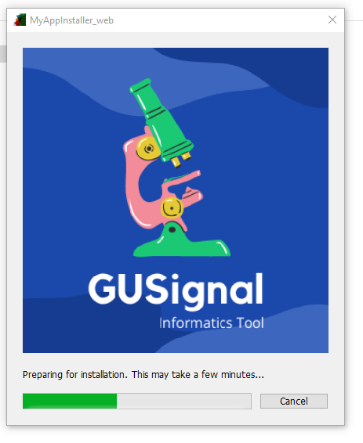

1. A window with the software description appears. Click on “Next”

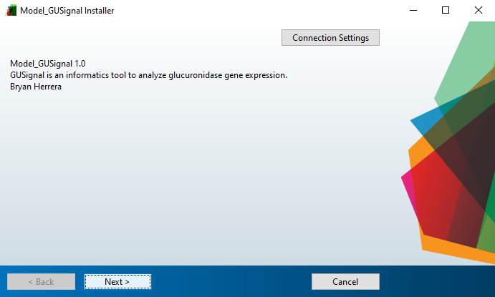

1. Choose installation folder and click on “Next”. (It is advisable to select the option “Add a shortcut to the desktop”).

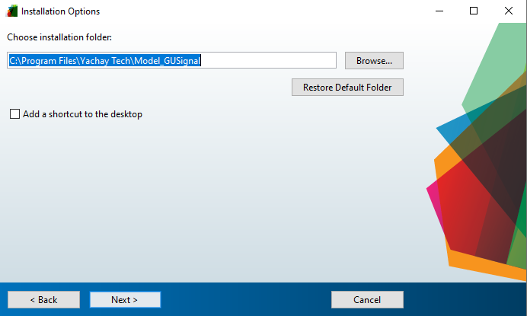

1. A window with the required software “MATLAB Runtime” appears. Click on Next.

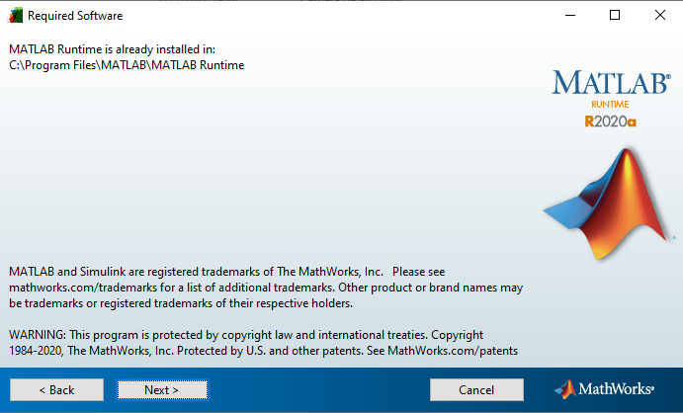

1. The installation will start and when it is finished, click on “Finish”.

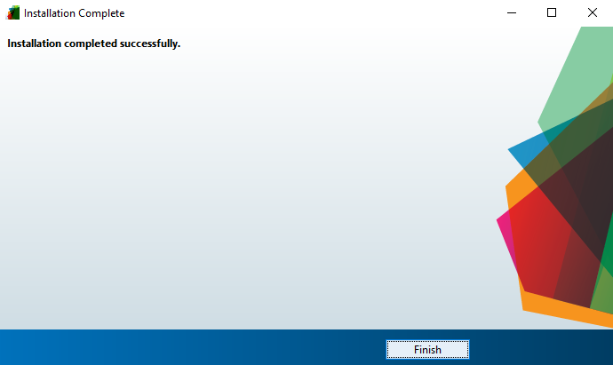

1. Finally, open the "Model_GUSignal" folder, open the "for_redistribution_files_only" folder and open the "Model_GUSignal" application. If you select the option “Add a shortcut to the desktop” in the step 5, can go to the desktop and open the “Model_GUSignal” application directly.

 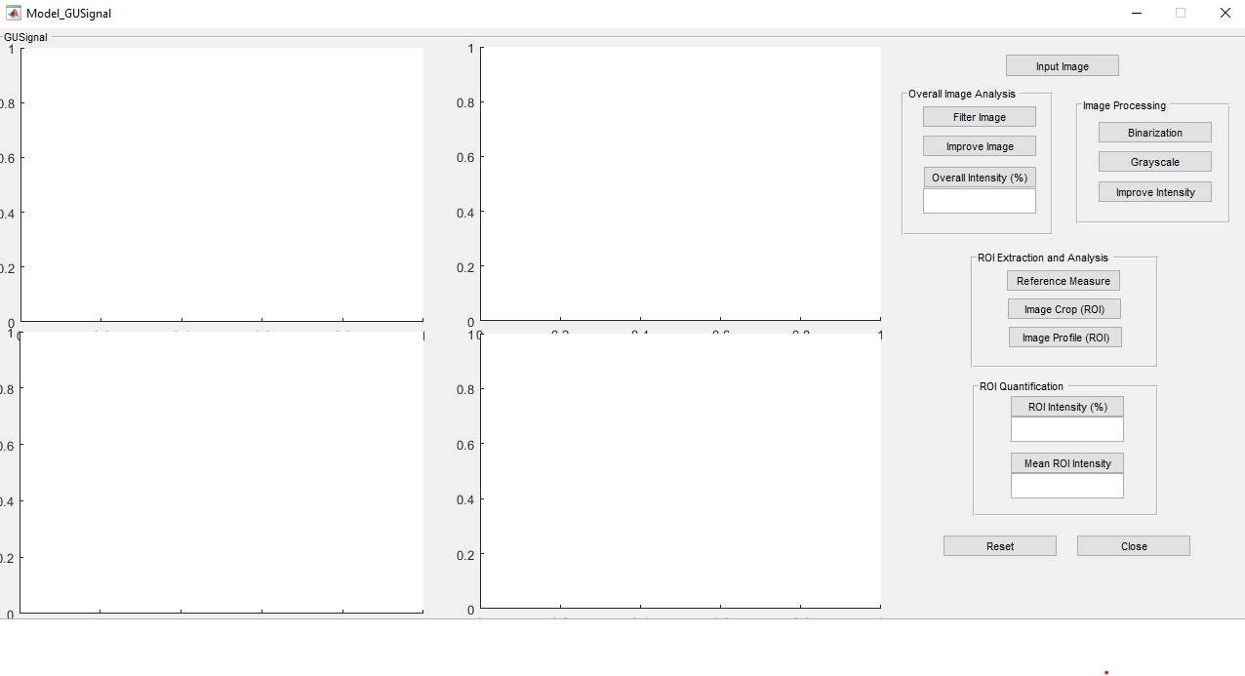

***\*Note: For testing the Software, continued in Folder 3: Software Management Instructions***